|  |
| --- |
| **FINAL PROJECT** |
| Submitted by:  MUHAMMAD DANIYAL ZAFAR FA18-BCS-061 BCS-5A-A  Submitted to:  SIR ASHFAQ FAROOQI |
| RESTAURANT MANAGEMENT SYSTEM |
|  |

RESTAURANT MANAGEMENT SYSTEM

## Introduction

The Restaurant Management System helps the restaurant manager to manage the restaurant more effectively and efficiently by computerizing meal ordering and billing.

The system processes transaction and stores the resulting data. Manager can see all Orders Data.

This system also provide ease to customers. Customers can login to their id and can place order directly. This will save customers for being waiting in a queue.

## Entities

* Customer
* Food Item
* Order

## Class Diagram

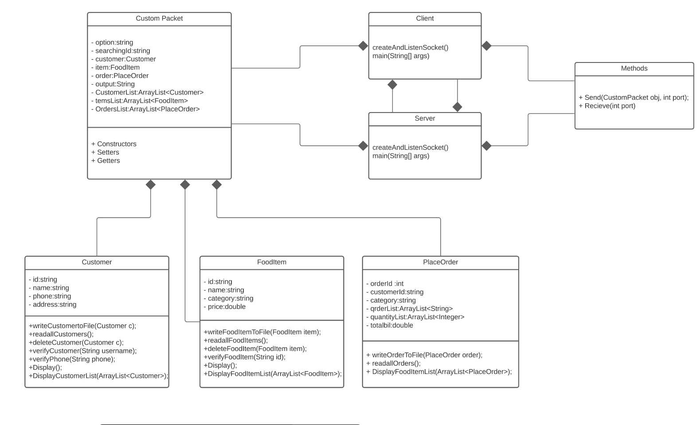

## Data Representation Mode

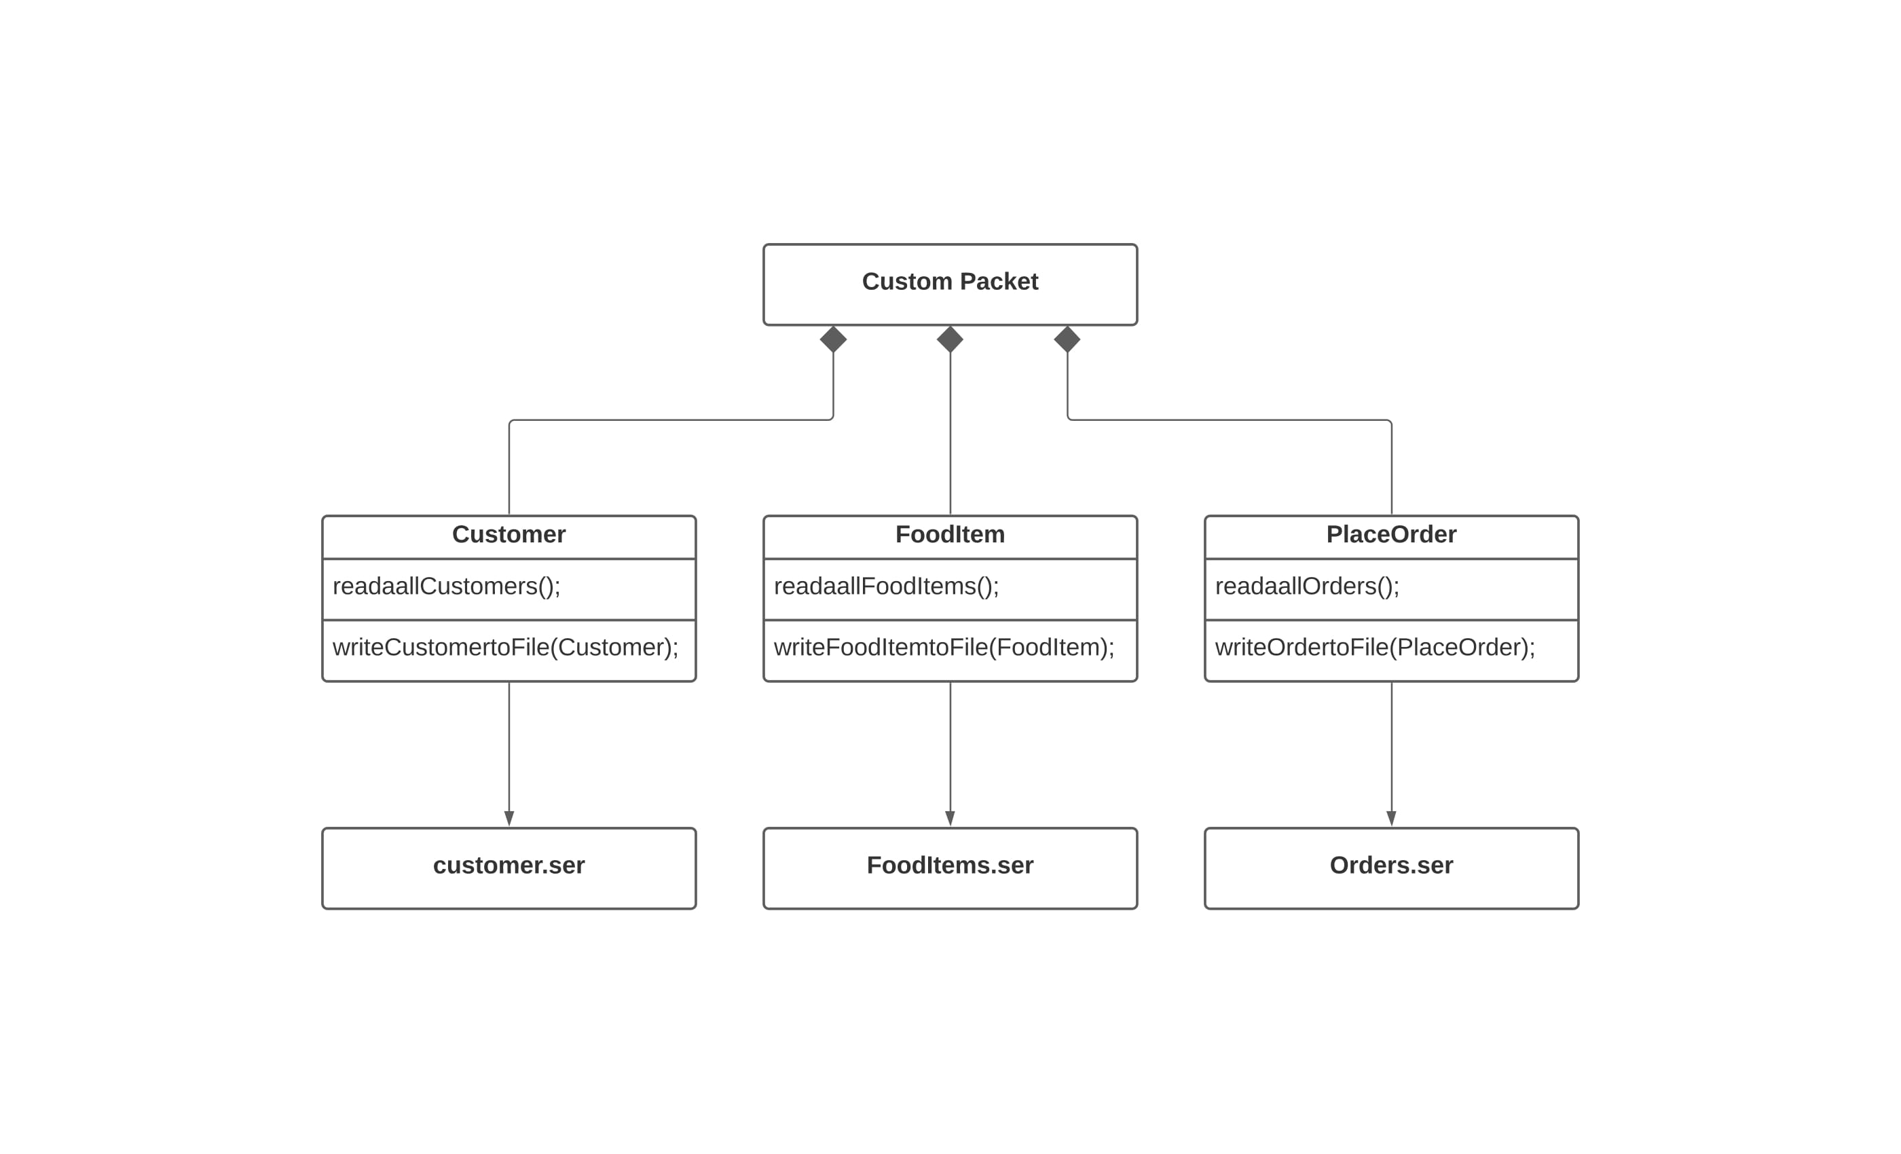

## Function of Classes

* Customer

Customer Class is used to make customer Object for Sign-up in customer section and Add customer in Admin Section. After that it is also used to display / update / delete Customers.

* Food Item

Food Item Class is used to make Item Object Add Food Item from Admin Section. After that it is also used to order / display / update / delete Food Items.

* Place Order

Place Order Class is used to create order of Food Item for Customer. Customer can himself create order in customer section or admin create order and generate bill for customer. This class create relation between Customer and Food Item

* Client

This class is used to handle client-side operations. It gives different options for the client (customer / admin) like Login, Sign-up, Place order for customer AND Login, generate bill, add/delete/update customer add food items.

* Server

This class is used to perform operation what the client wants. When client want some operation, the application sends his input to the server the server performs some operations and return output to the application.

* Methods

This class contains sending and receiving methods that are used by client and server to make communication.

## Output

Main Menu

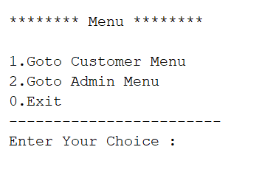

Customer Menu

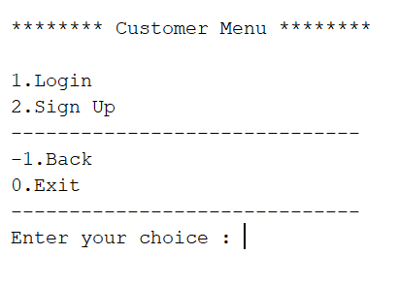

### Login Section

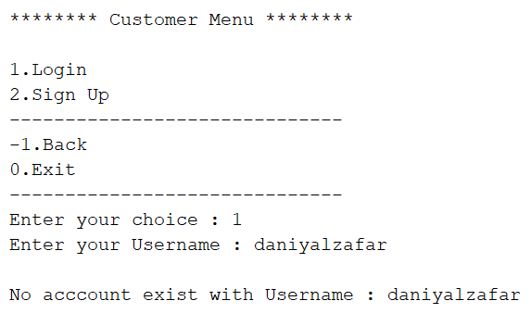

### Sign-up Form

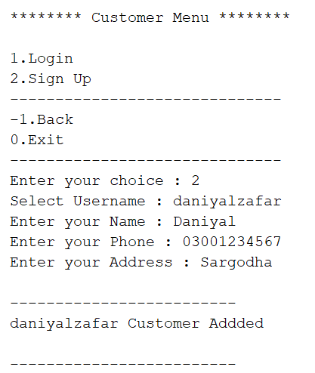

### Customer Choices

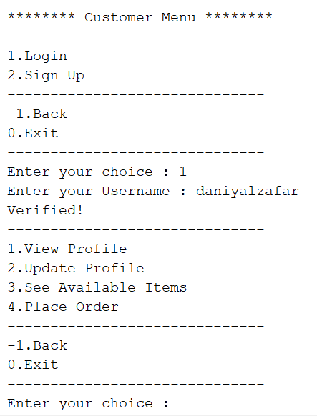

### User Profile

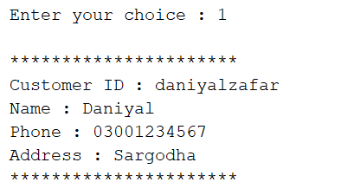

### Update Profile

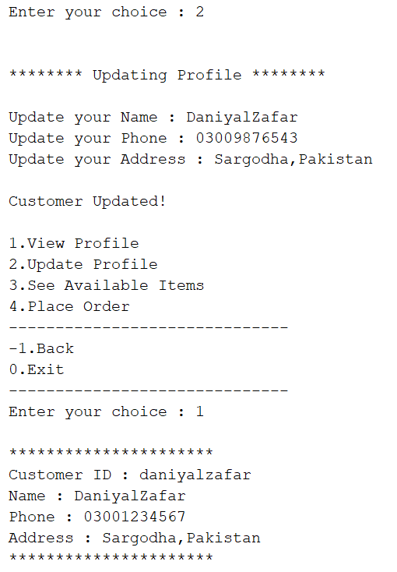

### Available Items

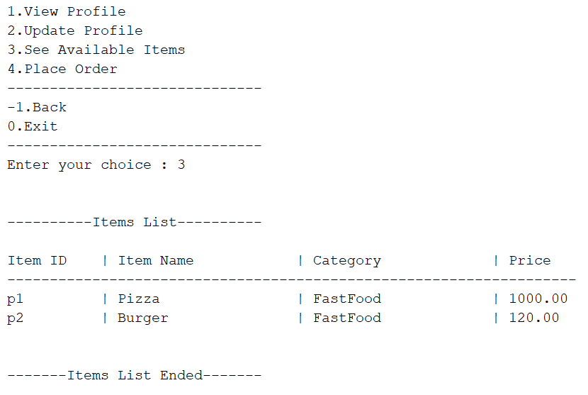

### Place Order

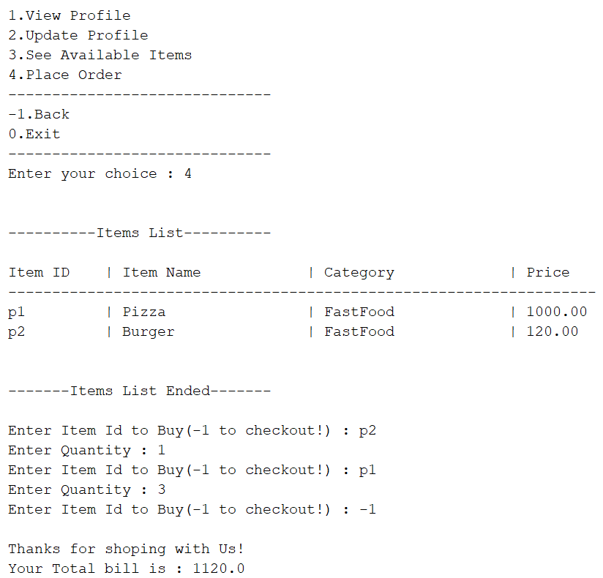

Admin Menu

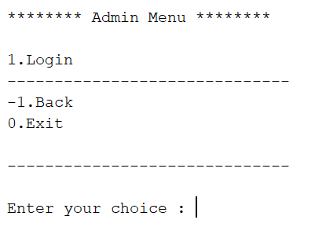

### Admin Choices

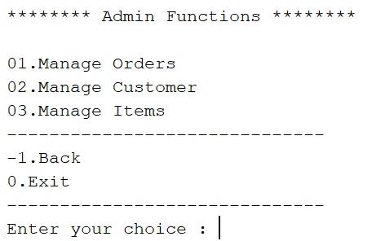

### Generate Bill

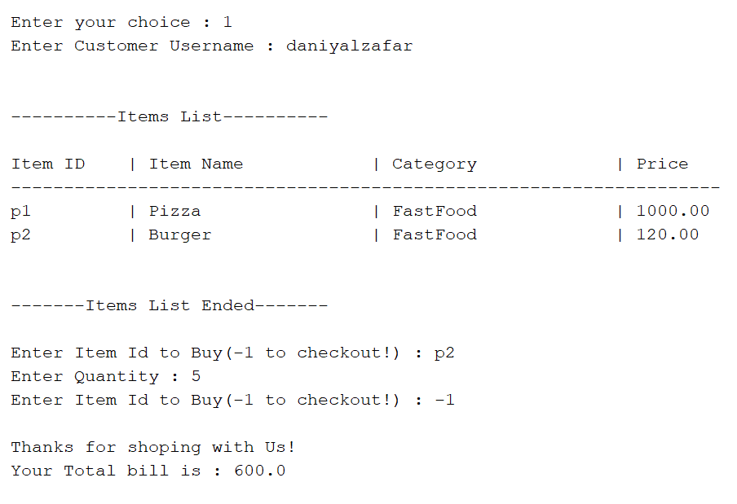

### See all Orders

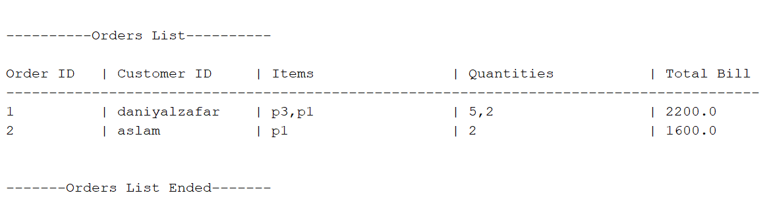

### Add Customer

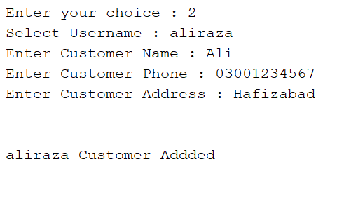

### View all Customers

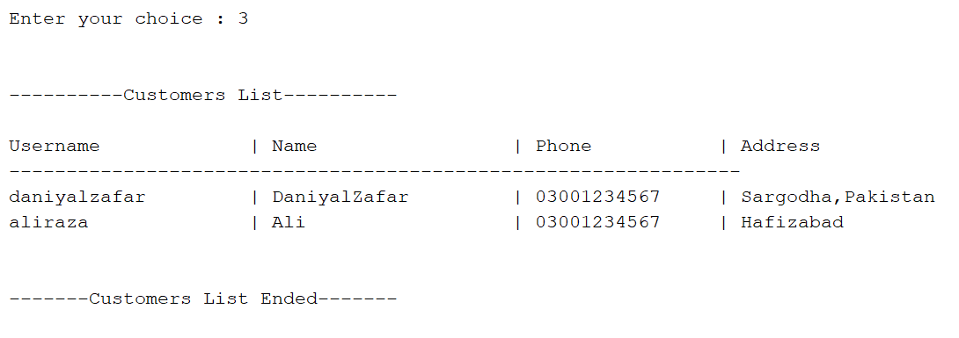

### Update Customer

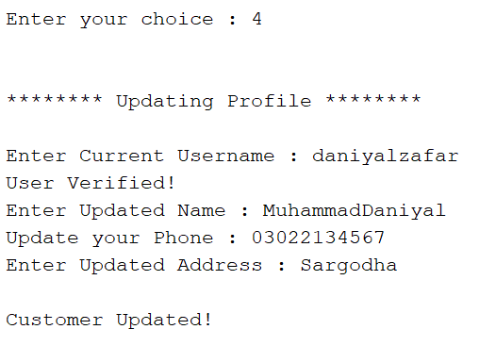

### Remove Customer Profile

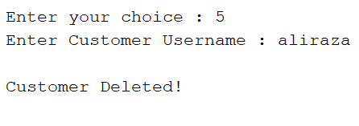

### Add Item

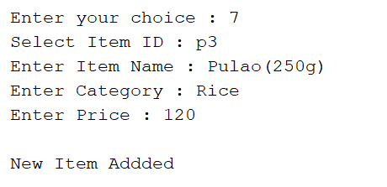

### View all Items

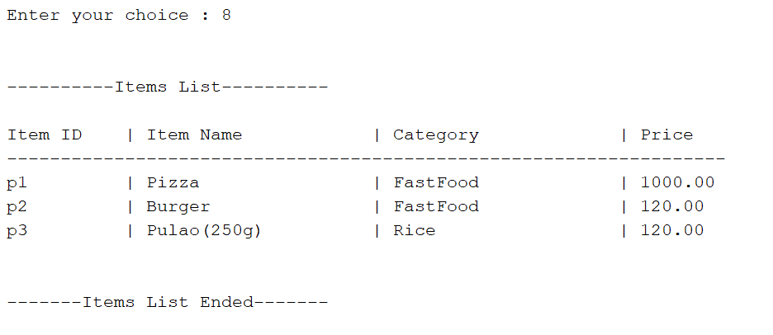

### Update Item

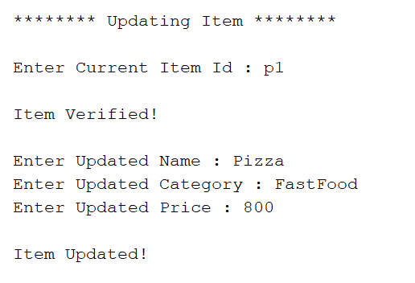

### Delete Item

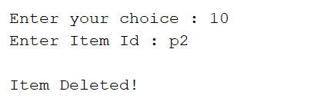

### Search Item

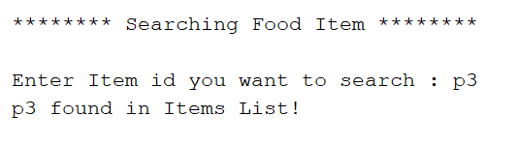

Exit

